Useful words for describing

Create a sentence using the following ‘power’ verbs.

grabbed
snatched
sprinted
scrambled
shouted
screamed
crawled
leapt
strode
yelled

exclaimed
glared

Examples of Writing Prompts
The following are twenty writing prompts that you could use to spark your imagination. If you want to use one, don’t worry about where the ideas take you or whether what you’ve written is “good”. The point is just to get into the flow of writing. You can come back later and polish if you wish to.

- It was the first snowfall of the year.
- He hadn’t seen her since the day they left High School.
- The city burned, fire lighting up the night sky.
- Silk.
- She studied her face in the mirror.
- The smell of freshly-cut grass.
- They came back every year to lay flowers at the spot.
- The streets were deserted. Where was everyone? Where had they all gone?
- This time her boss had gone too far.
- Red eyes.
- Stars blazed in the night sky.
- He woke to birdsong.
- ‘Shh! Hear that?’ ‘I didn’t hear anything.’
- He’d always hated speaking in public.
- She woke, shivering, in the dark of the night.
- The garden was overgrown now.
- He’d never noticed a door there before.
- She’d have to hitch a ride home.
- ‘I told him not to come back too!’
- His feet were already numb. He should have listened.

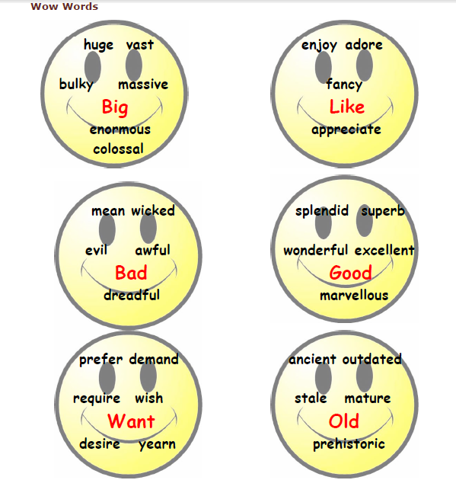

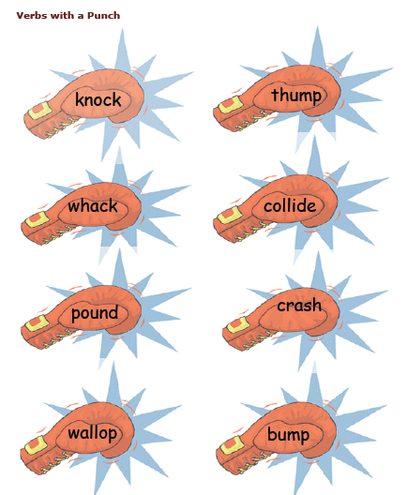

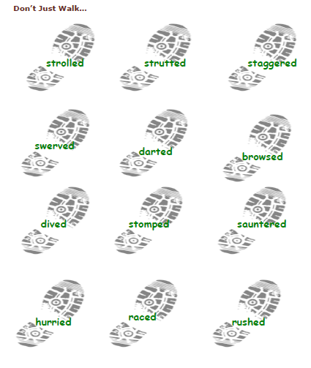

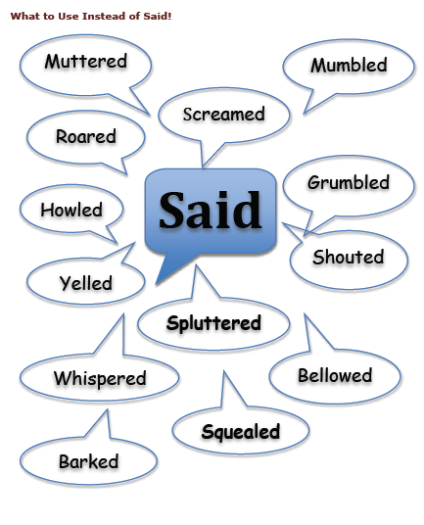

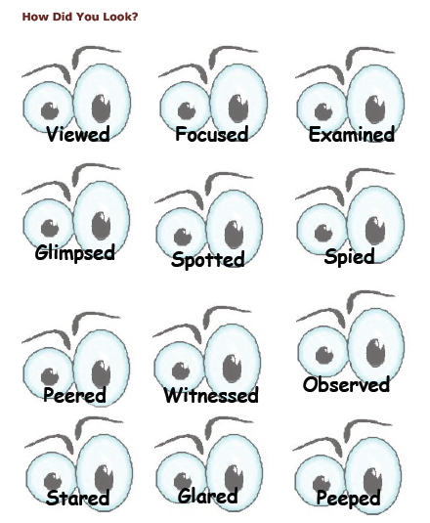

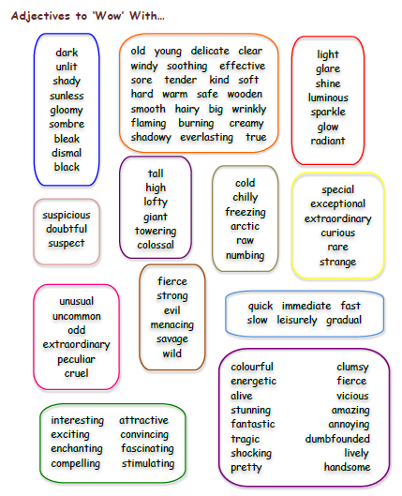

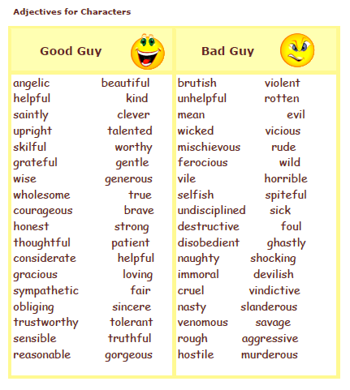

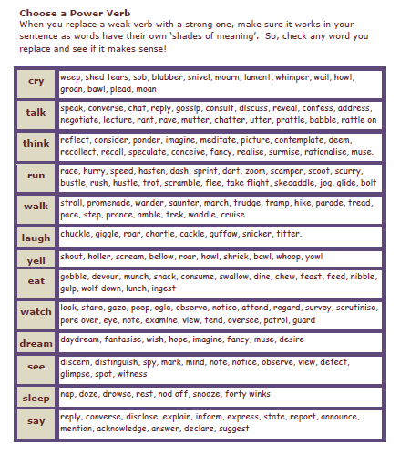

EXTRA:

Beautiful Words

Amorphous: indefinite, shapeless
Beguile: deceive
Caprice: impulse
Cascade: steep waterfall
Cashmere: fine, delicate wool
Chrysalis: protective covering
Cinnamon: an aromatic spice; its soft brown color
Coalesce: unite, or fuse
Crepuscular: dim, or twilit
Crystalline: clear, or sparkling
Desultory: half-hearted, meandering
Diaphanous: gauzy
Dulcet: sweet
Ebullient: enthusiastic
Effervescent: bubbly
Elision: omission
Enchanted: charmed
Encompass: surround
Enrapture: delighted
Ephemeral: fleeting
Epiphany: revelation
Epitome: embodiment of the ideal
Ethereal: celestial, unworldly, immaterial
Etiquette: proper conduct
Evanescent: fleeting
Evocative: suggestive
Exuberant: abundant, unrestrained, outsize
Felicity: happiness, pleasantness
Filament: thread, strand
Halcyon: care-free
Idyllic: contentedly pleasing
Incorporeal: without form
Incandescent: glowing, radiant, brilliant, zealous
Ineffable: indescribable, unspeakable
Inexorable: relentless
Insouciance: nonchalance
Iridescent: luster
Languid: slow, listless
Lassitude: fatigue
Lilt: cheerful or buoyant song or movement
Lithe: flexible, graceful
Lullaby: soothing song
Luminescence: dim chemical or organic light
Mellifluous: smooth, sweet
Mist: cloudy moisture, or similar literal or virtual obstacle
Murmur: soothing sound
Myriad: great number
Nebulous: indistinct
Opulent: ostentatious
Penumbra: shade, shroud, fringe
Plethora: abundance
Quiescent: peaceful
Quintessential: most purely representative or typical
Radiant: glowing
Redolent: aromatic, evocative
Resonant: echoing, evocative
Resplendent: shining
Rhapsodic: intensely emotional
Sapphire: rich, deep bluish purple
Scintilla: trace
Serendipitous: chance
Serene: peaceful
Somnolent: drowsy, sleep inducing
Sonorous: loud, impressive, imposing
Spherical: ball-like, globular
Sublime: exalted, transcendent
Succulent: juicy, tasty, rich
Suffuse: flushed, full
Susurration: whispering
Symphony: harmonious assemblage
Talisman: charm, magical device
Tessellated: checkered in pattern
Tranquility: peacefulness
Vestige: trace
Zenith: highest point

Ugly Words

Cacophony: confused noise
Cataclysm: flood, catastrophe, upheaval
Chafe: irritate, abrade
Coarse: common, crude, rough, harsh
Cynical: distrustful, self-interested
Decrepit: worn-out, run-down
Disgust: aversion, distaste
Grimace: expression of disgust or pain
Grotesque: distorted, bizarre
Harangue: rant
Hirsute: hairy
Hoarse: harsh, grating
Leech: parasite,
Maladroit: clumsy
Mediocre: ordinary, of low quality
Obstreperous: noisy, unruly
Rancid: offensive, smelly
Repugnant: distasteful
Repulsive: disgusting
Shriek: sharp, screeching sound
Shrill: high-pitched sound
Shun: avoid, ostracize
Slaughter: butcher, carnage
Unctuous: smug, ingratiating
Visceral: crude, anatomically graphic

Scary vocabulary

- scary
provoking fear terror
- chilling
the process of becoming cooler; a falling temperature
- shivery
cold enough to cause shivers
- terrorize
coerce by violence or with threats
- terrify
fill with terror; frighten greatly
- scourge
something causing misery or death
- threat
declaration of an intention or a determination to inflict harm on another
- holy terror
a very troublesome child
- panic
an overwhelming feeling of fear and anxiety
- fear
an emotion experienced in anticipation of some specific pain or danger (usually accompanied by a desire to flee or fight)
- venerate
regard with feelings of respect and reverence; consider hallowed or exalted or be in awe of
- fright
an emotion experienced in anticipation of some specific pain or danger (usually accompanied by a desire to flee or fight)
- fearfulness
an emotion experienced in anticipation of some specific pain or danger (usually accompanied by a desire to flee or fight)
- dread
fearful expectation or anticipation
- frighten
cause fear in
- scare
cause fear in
- freak
a person or animal that is markedly unusual or deformed
- monstrosity
a person or animal that is markedly unusual or deformed
- lusus naturae
a person or animal that is markedly unusual or deformed
- demon
an evil supernatural being
- devil
an evil supernatural being
- fiend
an evil supernatural being
- ogre
(folklore) a giant who likes to eat human beings
- imaginary being
a creature of the imagination; a person that exists only in legends or myths or fiction
- imaginary creature
a creature of the imagination; a person that exists only in legends or myths or fiction
- freak out
lose one's nerve
- gross out
fill with distaste
- pitch blackness
total absence of light
- total darkness
total absence of light
- black
being of the achromatic color of maximum darkness; having little or no hue owing to absorption of almost all incident light
- blackness
total absence of light
- sinister
stemming from evil characteristics or forces; wicked or dishonorable
- bleak
unpleasantly cold and damp
- fatal
bringing death
- sinistral
of or on the left
- menacing
threatening or foreshadowing evil or tragic developments
- ugly
displeasing to the senses

Word List and Vocabulary
Alphalary for Halloween (321)
A) Abhorrent, Abode, Adventure, Affect, Afraid, Allure, Alone, Amulet, Annihilate, Antics, Apparition, Awesome

B) Babble, Banshee, Basket, Bats, Bats, Beasts, Bevy, Bewitching, Black, Black cat, Black cats, Black magic, Blood curdling, Bloody, Bobbing, Bones, Bony, Boo, Boogie-man, Booty, Brew, Brimstone, Broom, Bubbling

C) Cackle, Candles, Candy, Candy corn, Captivate, Careful, Carvings, Cat, Cauldron, Caution, Cemetery, Ceremonies, Charms, Chills, Clairvoyant, Cloak, Cloudy, Clove of garlic, Cobwebs, Cockroach, Coffin, Collect, Concoction, Conjure, Contort, Costume, Coven, Crawling, Crazed, Creaking, Creepy, Cringe, Crone, Crypt, Curses

D) Dank, Dark, Dearly departed, Decapitated, Decomposed, Decorations, Dematerialize, Demon, Devil, Dim, Disgusting, Dismal, Diviner, Doomed, Dracula, Dragon, Druids, Dunk for apples, Dusk

E) Eek, Eerie, Effect, Elf, Enchant, Enchantress, Entertaining, Entice, Entomb, Entrance, Escapade, Evil, Exhume

F) Face paint, Fairy, Fear, Feasting, Fiend, Foggy, Fortuneteller, Foul, Frankenstein, Freak, Fright, Frighten, Frightful, Frozen to the spot, Frozen with fear, Fury

G) Gasp, Ghastly, Ghastly, Ghost, Ghost, Ghoul, Gnarl, Gnome, Goblin, Goose bumps, Goose flesh, Gory, Gourd, Grave, Gremlin, Grim Reaper, Groaning, Gross, Grotesque, Gruesome

H) Hackles, Hag, Hallucinate, Haunt, Haven, Headless horseman, Hecate, Heinous, Hex, Hobble, Hobgoblin, Horrible, Horrify, Horseman, Hover, Howl, Hysterical

I) Imitate, Imp, Infect, Influence

J) Jabber, Jack-o-lantern, Jinx, Jokes

K) Keen, Keeper

L) Labyrinth, Lantern, Leprechaun, Lunacy, Lunar, Lycanthrope

M) Macabre, Maggot, Magic, Magic spells, Magical, Maniac, Manifestation, Maraud, Mask, Maze, Mesmerize, Metamorphosis, Miasma, Moan, Moldy, Monster, Moon, Mournful, Mummy, Mutation, Mysterious, Mystery, Mystical

N) Netherworld, Newt, Nightmarish, Noisemaker, Noisy, Nonsense

O) Obscure, Occultism, Occurrences, Ogre, Orange, Outer limit, Outfit

P) Parade, Pendant, Pentagram, Petrify, Phantasm, Phantom, Phenomenon, Possess, Potions, Prank, Premonition, Prey, Prowl, Psychic, Pumpkin, Purple

Q) Quake, Quest, Quiver

R) Rasp, Rattle, Repugnant, Revolting, Ritual, Roar, Rote

S) Sarcophagus, Scar, Scare, Scared, Scream, Screech, Scythe, Seasonal, Seer, Shaman, Shiver, Shock, Shrew, Shriek, Sibyl, Sinister, Skeleton, Skitter, Skulk, Skull, Skull-duggery, Slink, Soothsayer, Sorcerer, Sorcery, Soul, Specter, Spectral, Spell, Spellbound, Spider, Spine-tingling, Spirit, Spook, Stuff, Supernatural, Superstition, Supervision, Supplies, Suspicious, Swarm

T) Tactic, Terror, Terrorize, Toads, Tomb, Tortured, Treasure, Trick or treat, Trickery, Troll, Twilight

U) Ugly, Uneasy, Unexpected, Unexplained, Unleash, Unmask

V) Vampire, Vein, Vixen, Voodoo

W) Wail, Wandering, Warlords, Wart, Waylay, Weird, Whisper, Whistle, Wicked, Wild, Witch, Witchcraft, Witchdoctor, Wizard, Wolf man, Wooden stake, Worrisome

X)

Y) Yells, Yelp

Z) Zap, Zombie, Zone, Zorro

Halloween Vocabulary Word List

A  afraid  afterlife  alarming  alien  angel  apparition  astronaut  autumn  B  ballerina  bat  beast  bizarre  black  black cat  blood  bloodcurdling  bogeyman  bone  boo  broomstick  C  cackle  cadaver  candy  cape  carve  casket  cat  cauldron  cemetery  chilling  cloak  clown  cobweb  coffin  corpse  costume  cowboy  cowgirl  creepy  crown  crypt | D  dark  darkness  dead  demon  devil  devilish  disguise  dreadful  death  dress-up  E  eerie  elf  enchant  evil  eyeballs  eyepatch  F  face paint  fairy  fall  fangs  fantasy  fear  firefighter  flashlight  fog  fright  frighten  frightening  frightful  G  genie  ghastly  ghost  ghostly  ghoul  ghoulish  goblin  goodies  gory  gown  grave  gravestone  grim  Grim Reaper  grisly  gruesome | H  hair-raising  Halloween  hat  haunt  haunted house  hayride  headstone  hobgoblin  hocus pocus  horrible  horrify  howl  I  imp  J  jack-o'-lantern  jumpsuit  K  kimono  king  L  lantern  M  macabre  make-believe  make-up  magic  magic wand  mask  masquerade  mausoleum  midnight  mist  monster  moon  moonlight  moonlit  morbid  mummy  mysterious  N  night  nightmare  ninja | O  October  ogre  orange  otherworldly  owl  P  party  petrify  phantasm  phantom  pirate  pitchfork  poltergeist  potion  prank  pretend  prince  princess  pumpkin  Q  queen  R  repulsive  revolting  RIP  robe  robot  S  scare  scarecrow  scary  scream  shadow  shadowy  shock  shocking  skeleton  skull  soldier  specter  spell  spider  spider web  spine-chilling  spirit | S cont.  spook  spooky  startling  strange  superhero  supernatural  superstition  sweets  T  tarantula  terrible  terrify  thirty-first  thrilling  tiara  toga  tomb  tombstone  treat  treats  trick  trick-or-treat  troll  tutu  U  unearthly  unnerving  V  vampire  vanish  W  wand  warlock  web  weird  werewolf  wicked  wig  witch  witchcraft  wizard  wizardry  wraith  Z  zombie

